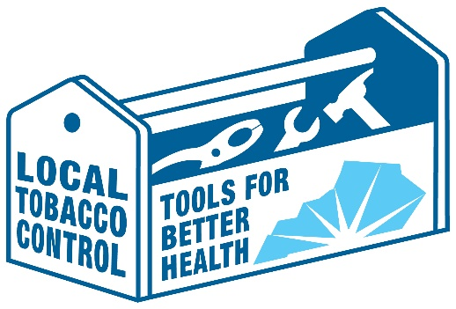
Local Tobacco Control
Social Media Toolkit

Suggested Social Media Posts to Accompany this Graphic:
- Most Kentucky voters say cities and counties should have the right to restrict tobacco marketing and sales to kids. Repeal the state ban on #LocalTobaccoControl www.smokefreetomorrow.org/priorities
- Want to reduce the taxes you pay for health issues associated with high tobacco use in your community? Repealing the state ban on #LocalTobaccoControl gives KY cities/counties more tools to improve health, reduce costs from #tobacco use. www.smokefreetomorrow.org/priorities
- Is your community ready to do more to reduce tobacco use? State law currently bars local control of tobacco marketing/sales. Repeal state ban on #LocalTobaccoControl www.smokefreetomorrow.org/priorities
- Communities often know best what's needed to improve health by reducing tobacco use. Repeal the state ban on #LocalTobaccoControl www.smokefreetomorrow.org/priorities

The toolbox image can also be downloaded online:
- Click on this link
- Right click on the image and select save as.

